**MapReduce**

Problem Statement

Question 2 : Find all time High price for each stock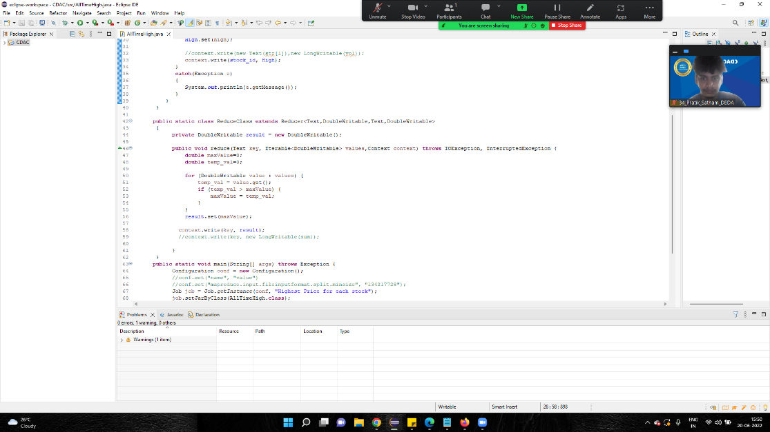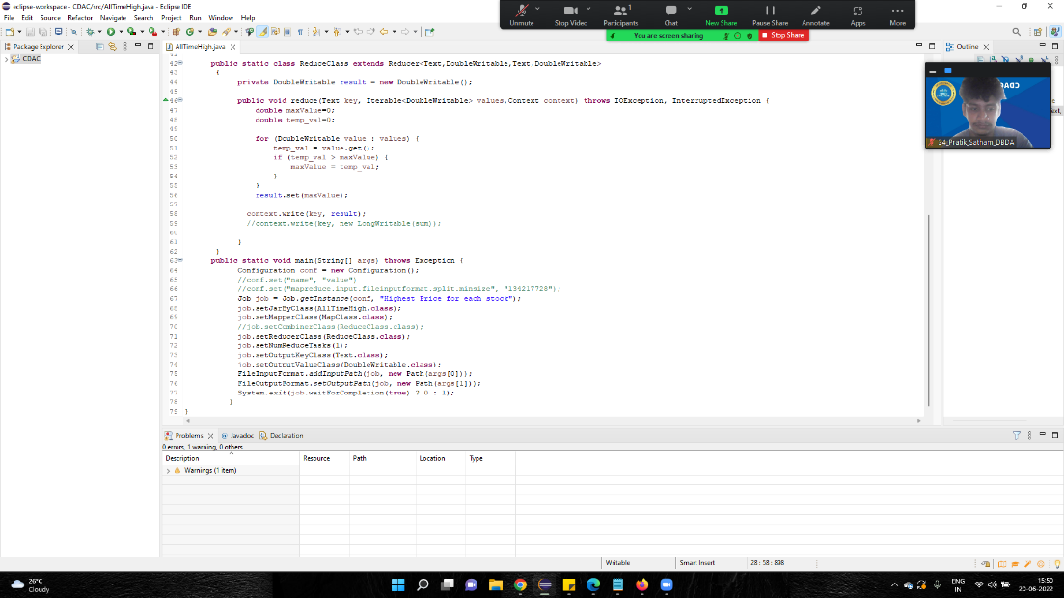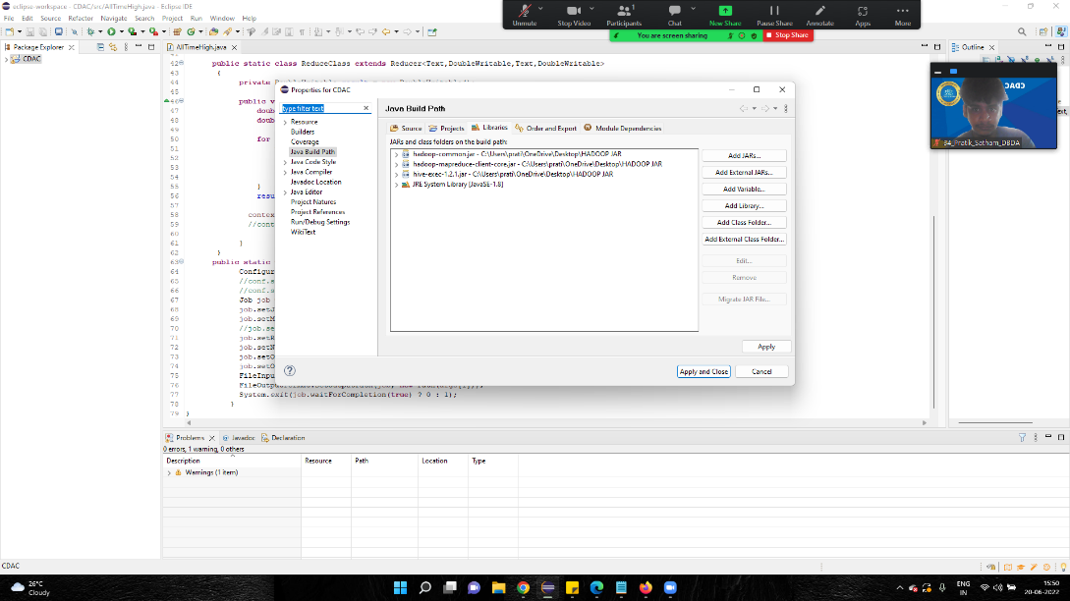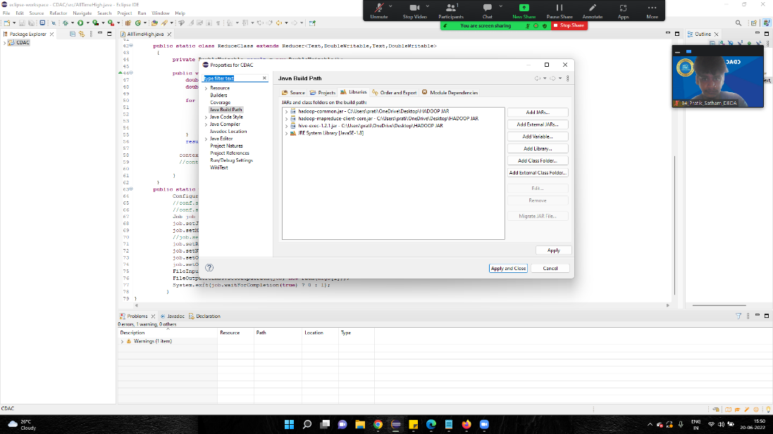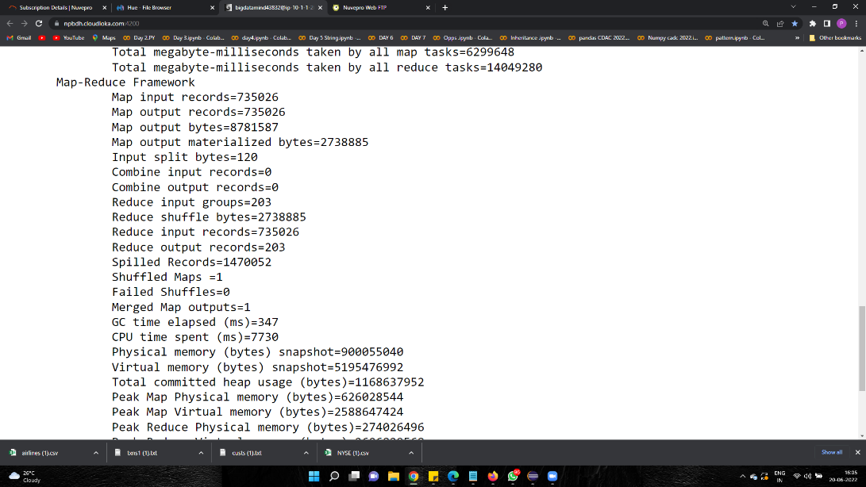

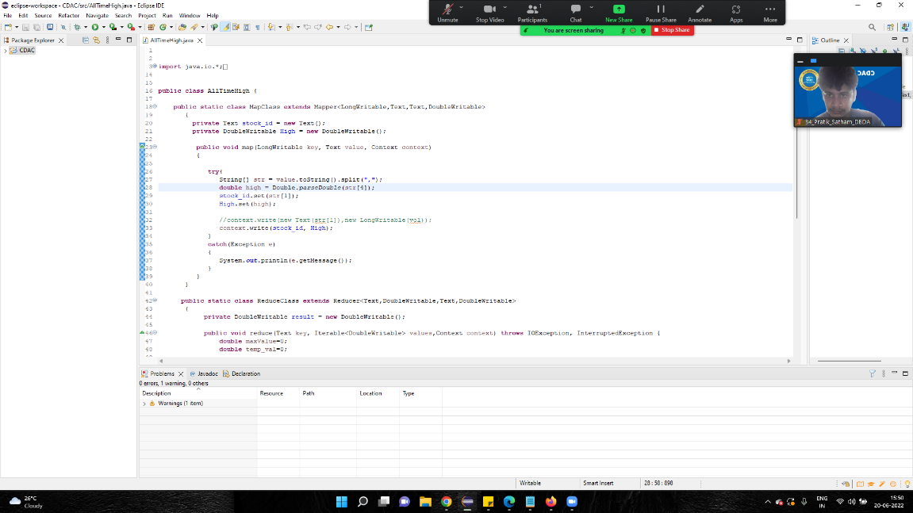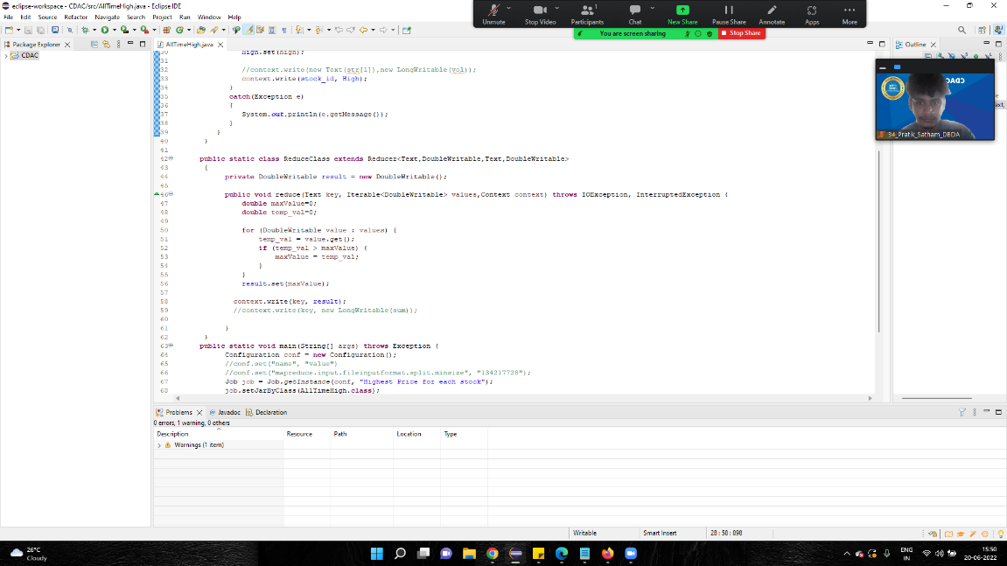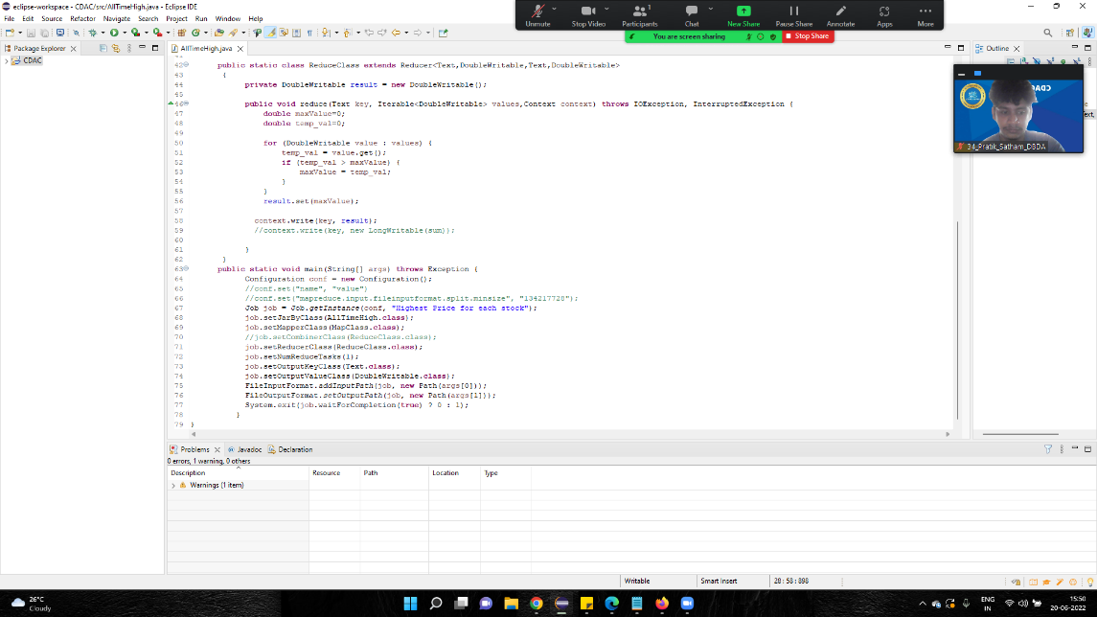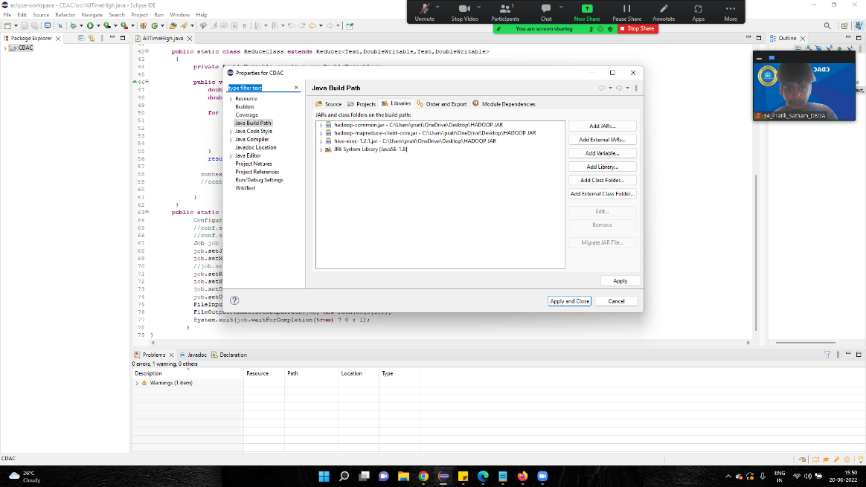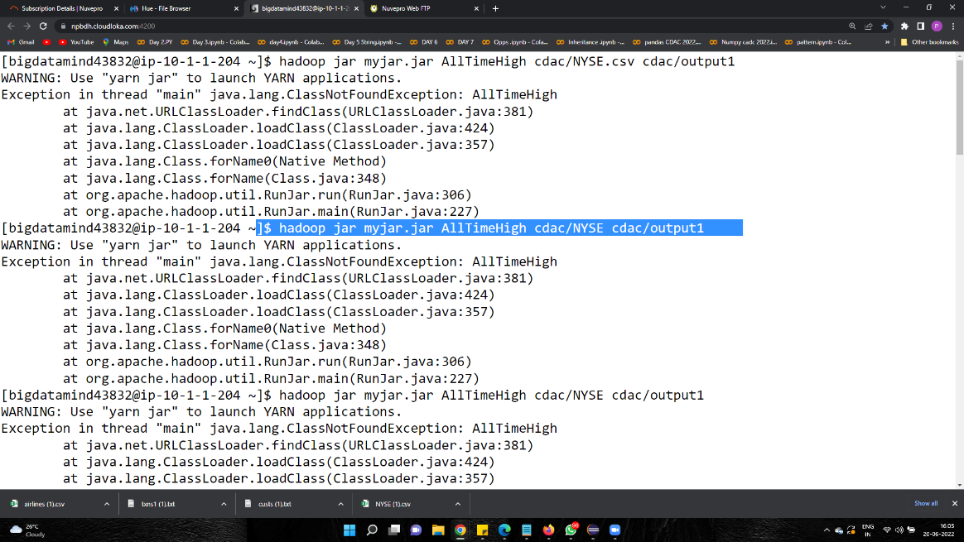

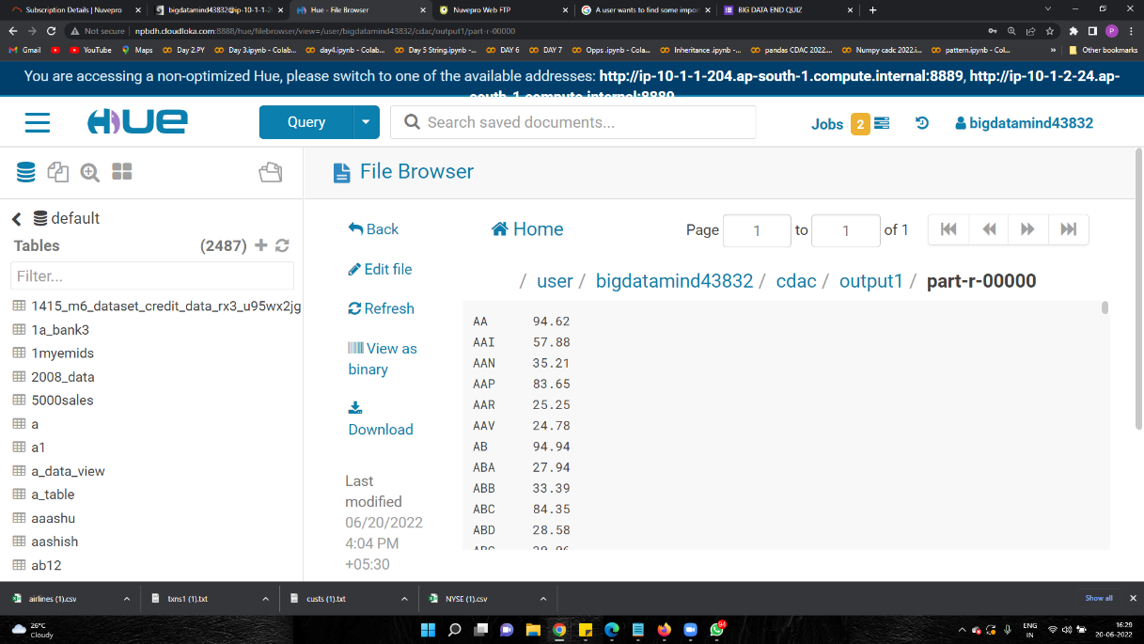

**Hive**

1. Write a program to find the count of customers for each profession.

hive> create table customer(custno int,firstname string,lastname string,age int,profession string)

> row format delimited

> fields terminated by ','

> stored as textfile;

OK

Time taken: 0.476 seconds

hive> load data local inpath 'custs.txt' into table customer;

Loading data to table training34.customer

OK

Time taken: 1.118 seconds

1. hive> select profession, count(*) as headcount from customer group by profession order by headcount;



2) Write a program to find the top 10 products sales wise

3) Write a program to create partiioned table on category

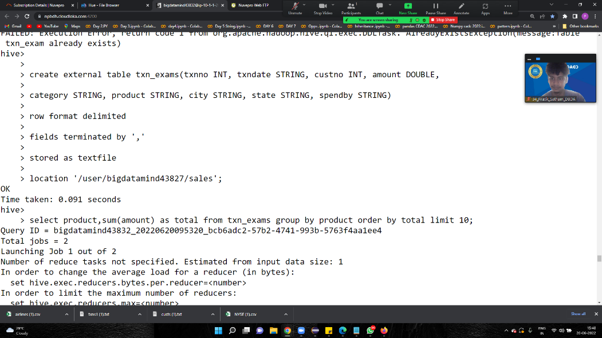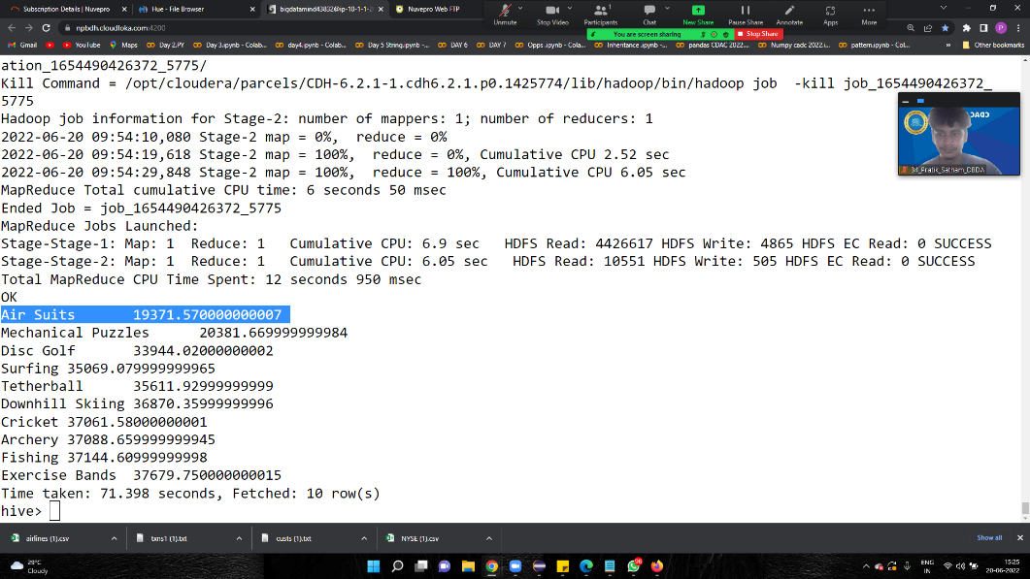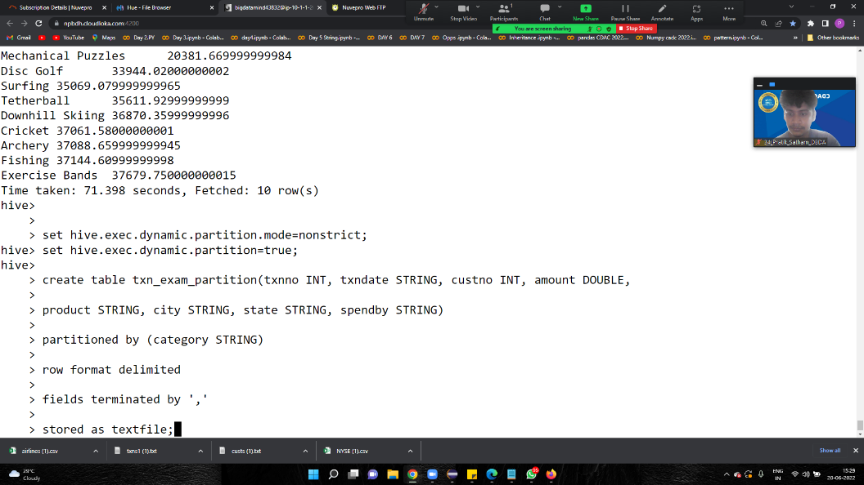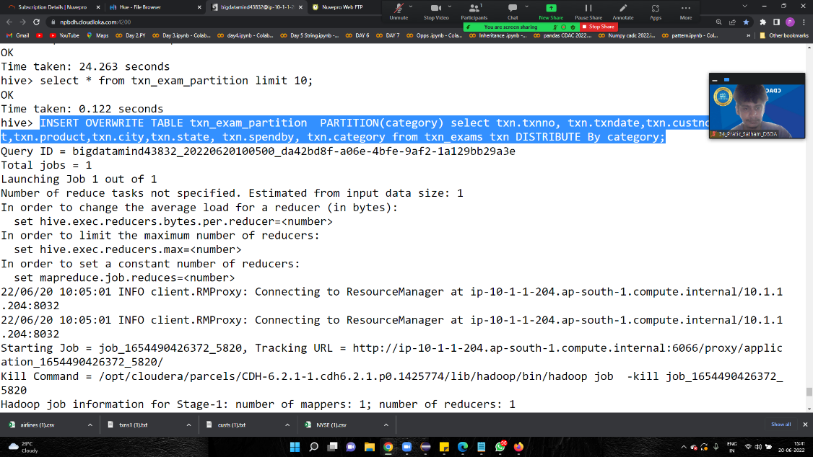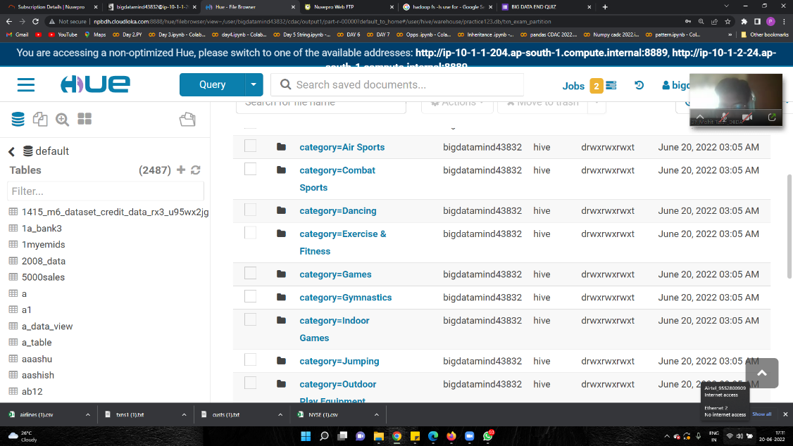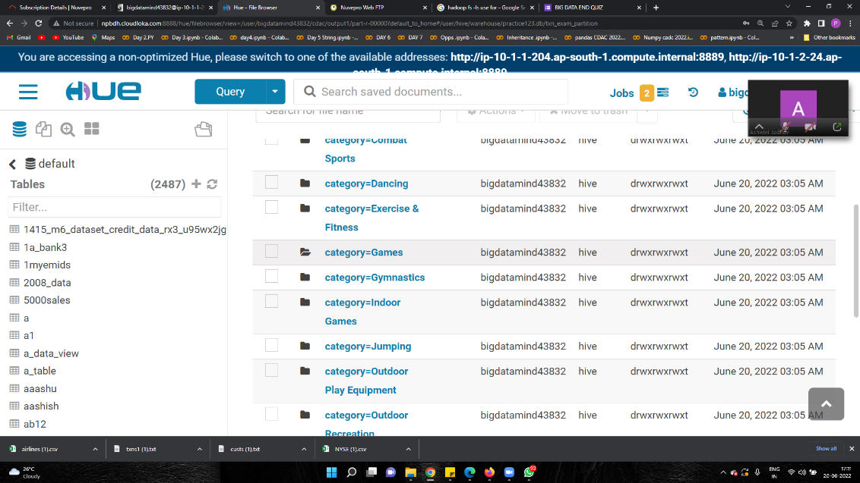

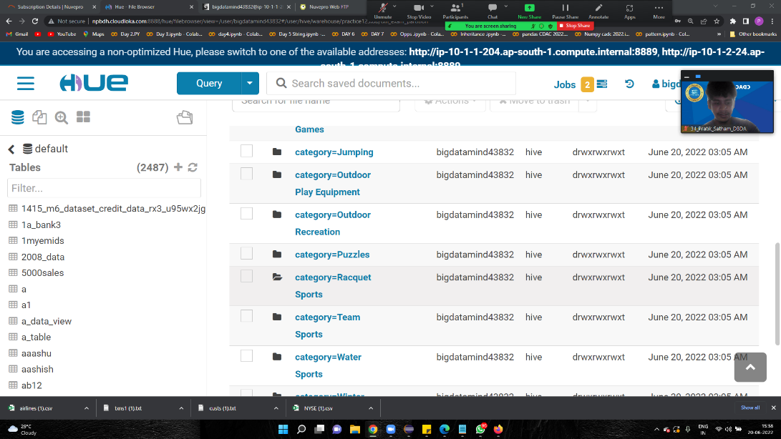

**Spark**

1) What was the highest number of people travelled in which year?

2) Identifying the highest revenue generation for which year

3) Identifying the highest revenue generation for which year and quarter (Common

group)

